



**Requirements specification**

***“ Doctor Appointment System ”***

**Name: Muhammad Danyal**

**Reg.No: 4304-BSSE-F21-B**

**Name: Nabeel Ahmad**

**Reg.No: 4315-BSSE-F21-B**

**Name: Furqan Ahmad Yousafzai**

**Reg.No: 4334-BSSE-F21-B**

**Name: Khalid Khan**

**Reg.No: 4362-BSSE-F21-B**

**Name: Abid Hakimi**

**Reg.No: 4363-BSSE-F21-B**

# Table of Contents

1. Introduction ................................................................................................................................... 3
   1. Purpose ................................................................................................................................... 3
   2. Scope ...................................................................................................................................... 4
   3. Definitions and Abbreviations …………............................................................................... 4
   4. Overview ................................................................................................................................ 5
2. Overall Description ....................................................................................................................... 6
   1. Product perspective ................................................................................................................ 6
   2. User characteristics................................................................................................................. 7
   3. Product functions ................................................................................................................... 9
      1. Major_use_cases...................................................................................................... 9
      2. UC2 refinement........................................................................................................ 16
   4. Expectations ........................................................................................................................... 20
      1. System expectations................................................................................................. 20
      2. Software expectation................................................................................................ 21
3. Specific Requirements .................................................................................................................. 22
   1. External Interface Requirements ............................................................................................ 22
   2. System Requirements ............................................................................................................. 22
   3. Functional Software Requirements ........................................................................................ 23
   4. Non-Functional Software Requirements ................................................................................ 25

# Introduction

Following document describes a new patient-doctor portal “Doctor Appointment System”, which allows to book time online for a doctor appointment and to store doctor related medical history in one place. Development of the doctor system and increasing the role of the online doctor appointment in our healthcare system is an important strategic objective of our team.

## Purpose

This requirements specification document describes the functions and requirements for a new patient portal called the Doctor Appointment System.

The main objective is:

1. To make the time booking process for doctor’s appointment more convenient by enabling real-time overview of free time slots and online booking possibilities.

Supportive objectives are:

1. To store all the relevant information for the patient in one system;
2. To enable patients to view and change their appointment times;
3. To allow patients to prepay visit fees if needed (mainly for patients who have no health insurance, but also for services not covered by health insurance);
4. To provide patients a view of their medical history from doctor visits and referral letters;
5. To create a calendar of reminders about health related actions. For example, schedule vaccination dates, follow-up appointments, health certificates renewals etc.

Currently the information about free slots for doctor appointments is mainly available via phone. Doctor Appointment System will enable better schedule planning and finding suitable slots, as the information would be accessible via web.

## Scope

New portal will allow patients to book/change time to their doctor online. This will solve long call que problems which is an important issue for most doctors. Portal will also contain patient’s medical history; including test results, vaccinations, previous doctor visits and other information that doctor wants to share with patient. Having this information online and available to patient will help to solve doctors’ work overload problem, because there will be less phone calls from the patients doctor has to answer to (asking test results, vaccination deadlines etc). New portal will enable doctors to send reminders to patients about upcoming vaccination and other visit deadlines. This will improve healthcare quality and save time for both doctors and patients.New portal will be web-based online application that is available on all major browsers. Portal should be user friendly in all usual devices (PC, mobile, tablet).

## Definition and Abbreviations

Throughout the document following terminology and abbreviations are used:

**“Doctor Appointment System” -** Name of the new patient/doctor portal. Following specifications describe main functionalities of this portal.

**“System” -** In this context meant as Doctor Appointment System portal.

**“Appointment” –** In this context means a certain time for patient visit to doctor’s office that is booked through Doctor Appointment System. Appointment exists in the system from the moment it is booked by patient and until it is cancelled or realized in time.

**“Medical Specialist”** - Doctor specialized to a certain medical field.

**“Patient”** - Person who is included to the doctor list.

**“Representative”** - In the context of the current document a person who has a legal right and a duty to take care of another person.

**“User” -** In this context all portal users, who can be patient, doctor, or representative. This does not include system administrators.

## Overview

Following document gives overall description regarding the system and contains a list of functional and non-functional requirements.

Product overall description can be found in part 2. Part 2.1 gives short overview of the product. Part 2.2 describes user characteristics and relationship dependencies between main actors. Part 2.3 shows Use Case diagram and includes Use Case templates that cover Doctor and Patient interactions with the system. In part 2.3.1 UC2 was chosen as the most important activity of the system and was used for further refinement showing its main classes and domain model.

Specific requirements can be found from Table 1 in part 3. This part is divided into 4 blocks: external interface requirements (part 3.1), system requirements (part 3.2), functional software requirements (part 3.3) and non-functional software requirements (part 3.4).

# Overall Description

## Product perspective

**Interfaces:** Doctor Appointment System portal is planned to operate online, enabling access from all major browsers. Interface would also be mobile and tablet friendly.

**Users:** System users are in the following segments:

1. Doctor
2. Patient

i. Can also be “Representative”

1. Represented person
2. System Administrators

**Hardware:** System should run as an online environment. As there would be a login needed, then users might need to use ID-card reader in addition to PC (or use other identification method).

**Software:** All major web browsers applicable. System should follow the Responsive Web Design (RWD) criteria - an approach to web design that makes web pages render well on a variety of devices and window or screen sizes .

**Hardware constraints:** System and its database need to be protected in accordance to applicable laws to handle sensitive personal data.

## User characteristics

There are four main user groups of the Doctor Appointment System portal:

1. Patient – a person who got doctor appointment, and included to the doctor list. Patient’s main activities in Doctor Appointment System: looking for suitable free slots for doctor’s appointment, making prepayments for the visit, looking for their appointments and medical history.
2. Represented person – similar to the patient, but with different user access rights. Difference from the patient is that represented person has a representative who has user rights for his/her account. Represented person user rights are restricted allowing only viewing his/her medical data.
3. Doctor – Doctors working in specialized health care centers who needs to see and maintain the information about their appointment calendars, see and add information regarding their patients treatments and visits and add or edit there appointment schedule and confirm appointment.
4. System administrator – smaller group of people, having access to the Doctor Appointment System are system administrators and developers, who need to handle and manage system errors, take care of development items and are responsible for further system maintenance.

## Product functions

### Major use cases

To illustrate further Patients interaction with Doctor Appointment System portal Use Case diagram was created .

Use Case diagram shows on a higher level how chosen actors interact with the system.

Following Use Cases are connected to Functional Requirements where system interacts either with Doctor or Patient (including Representative or Represented person).

Connection between Functional Requirement and Use Case can be found in Specific Requirements (Table 1).

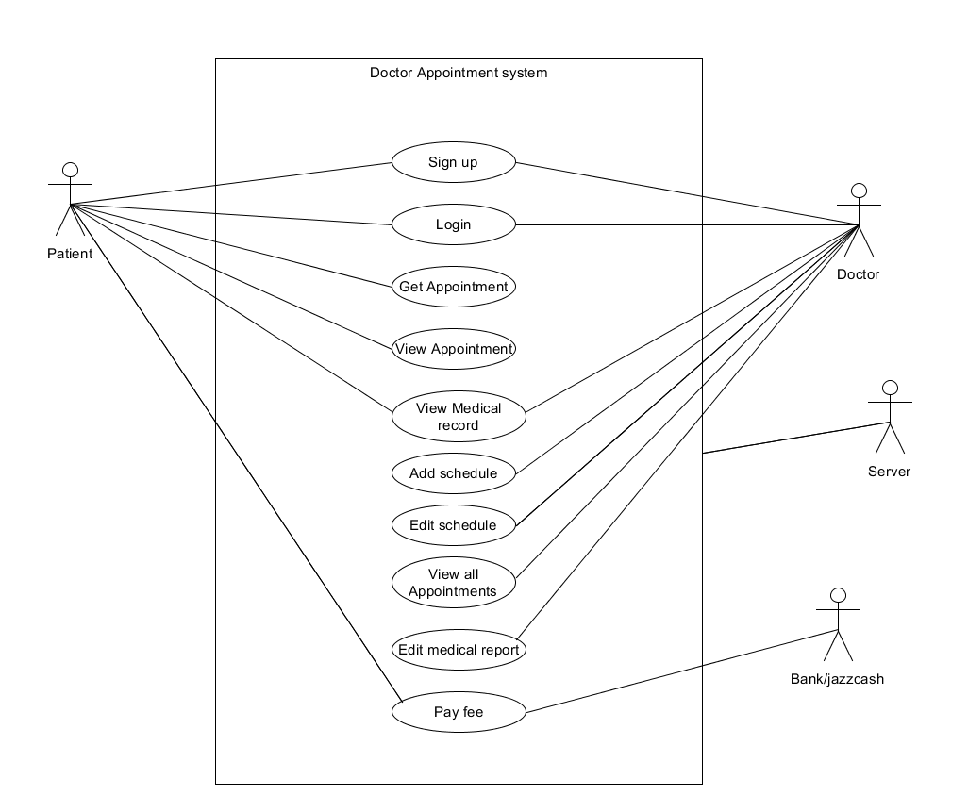

The most important use cases UC4, UC3, UC5, UC10 were selected and following Use Case templates filled for those:

|  |  |  |  |
| --- | --- | --- | --- |
| **Use Case ID** | UC 3 | | |
| **Use Case name** | Get Appointment | | |
| **Created By** | Group 3 | **Last Updated By** | Group 3 |
| **Date Created** | 20.10.2022 | **Date Last Updated** | 23.10.2022 |
| **Actors** | Patient | | |
| **Description** | Patient uses system to add new visit to the Doctors office. | | |
| **Trigger** | Patient wants to visit a doctor. | | |
| **Precondition** | • The patient is logged in to Doctor Appointment System. • System shows available time slots. | | |
| **Post-condition** | The system confirms the booking. | | |
| **Priority** | High | | |

|  |  |  |  |
| --- | --- | --- | --- |
| **Use Case ID** | UC 4 | | |
| **Use Case name** | View existing appointment | | |
| **Created By** | Group 3 | **Last Updated By** | Group 3 |
| **Date Created** | 20.10.2022 | **Date Last Updated** | 23.10.2022 |
| Actors | Patient | | |
| Description | Patient uses system to view an existing appointment | | |

|  |  |  |  |
| --- | --- | --- | --- |
| **Use Case ID** | UC 5 | | |
| **Use Case name** | View medical history | | |
| **Created By** | Group 3 | **Last Updated By** | Group 3 |
| **Date Created** | 20.10.2022 | **Date Last Updated** | 23.10.2022 |
| Actors | Patient and Doctor | | |
| Description | Patient uses system to view his/her medical data. | | |
| Trigger | Patient wants to view his/her medical history. | | |
| Precondition | * Patient is logged in to Doctor Appointment System. * Medical Staff has created and updated patient’s medical record. | | |
| Post-condition | System displays medical data to the user. | | |
| Priority | High | | |

|  |  |  |  |  |
| --- | --- | --- | --- | --- |
| **Use Case ID** | UC 10 | | | |
| **Use Case name** | Pay visit fees | | | |
| **Created By** | Group 3 | | **Last Updated By** | Group 3 |
| **Date Created** | 20.10.2022 | | **Date Last Updated** | 23.10.2022 |
| Actors | Patient | | | |
| Description | Patient uses the system to prepay the visit fee, if needed. | | | |
| Trigger | Patent needs to pay for the visit and prefers to do it online before the visit. | | | |
| Precondition | * The user is logged on to the system. * The user doesn’t have HIF insurance. * System displays the price for the visit. * System has online payment options available. | | | |
| Post-condition | The user has paid for the visit. | | | |
| Priority | Low |  | | |
| Includes | UC2 |  | | |

### UC2 refinement

As UC2 (get appointment) is one of the main and most important functions of Doctor Appointment System portal, it has been chosen for further refinement during which we will show in more details what classes are includes in this UC, how these classes are connected and what is the sequence of the activities between these classes. To achieve the goal of more detailed refinement for UC2 following diagrams were created: class diagram (CD1).

In the class diagram (Graph 7) there are four main classes: patient, medical staff, appointment and Doctor Appointment System portal. In addition to main classes patient has two sub-classes (representative and represented) and medical staff has also two sub-classes (nurse and doctor) which are based on the roles. CD1 shows relations between classes, sub-classes and main activities that are connecting these classes.

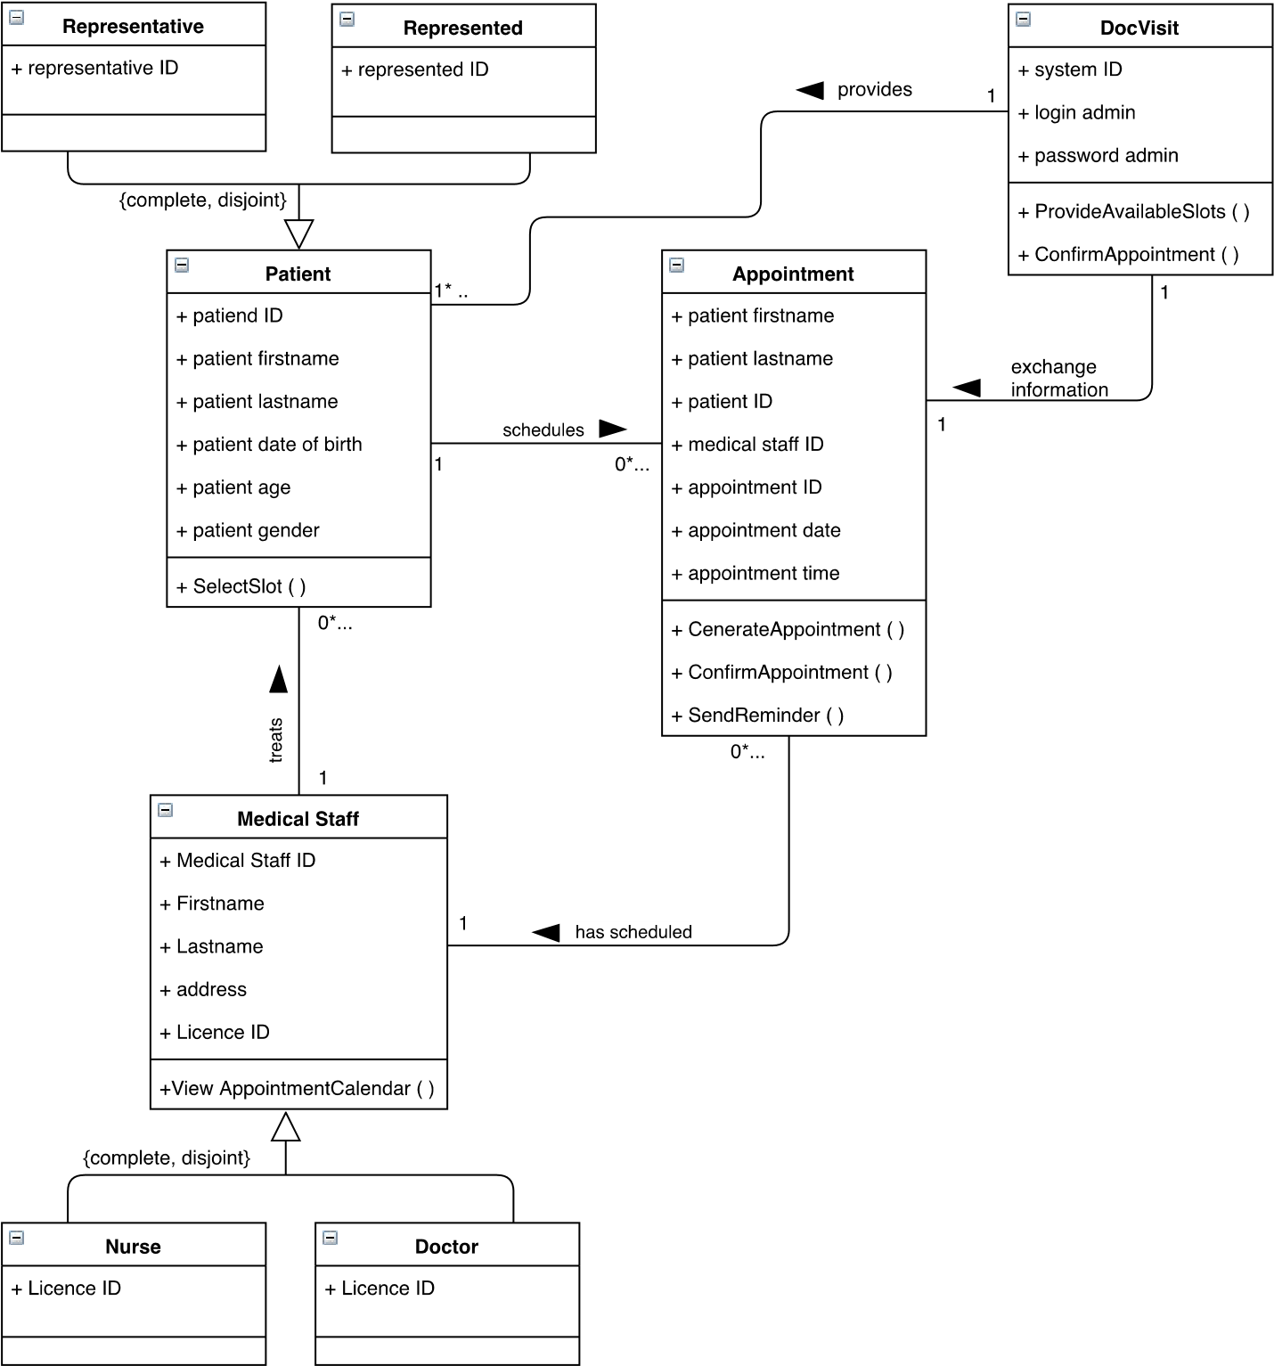

*Graph 7* CD1 *–* Class diagram of add new appointment use case

**Domain Model:**

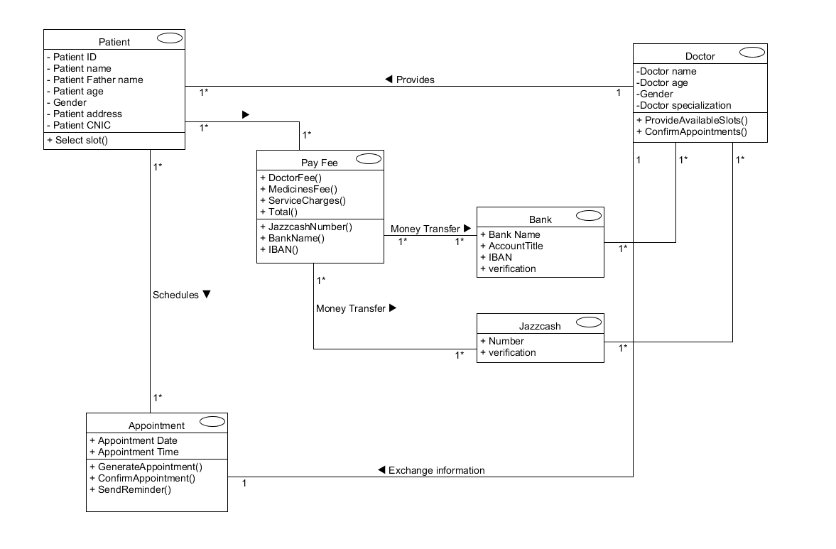

# Specific Requirements

*Table 1. Specific Requirements*

|  |  |  |  |  |  |  |
| --- | --- | --- | --- | --- | --- | --- |
| **Req. ID** | | **Requirement name** | | **Use**  **Case**  **ID** | **Category:**  **Mandatory (M)/ Nice to have (N)/Deleted** | **Priority**  **H(high)/ M(mediu**  **m)/L(low)** |
|  |  | | **3.1 External Interface Requirements** | | | |
| Req. 01 | | System should require user identification. | |  | M | M |
| Req. 02 | | System should support user identification by ID card. | |  | M | M |
| Req. 03 | | System should support user identification by Mobile ID. | |  | M | M |
| Req. 04 | | When user is logged in, the system should automatically connect patients to their doctors, so user sees only his/her applicable contacts. | |  | N | L |
|
|
| Req. 05 | | Time booking option and observing one’s medical history should be separated in the system user interface. | |  | N | L |
| Req. 06 | | Representative should have user rights of the represented person. | |  | M | M |
|
| Req. 07 | | Represented persons can log into the system to view their medical history, but can’t take any actions in the system. | |  | N | L |
|  |  | | **3.2 system Requirements** | | | |
| Req. 08 | | The system should be compliant with security standards applicable for handling sensitive personal and medical data. | |  | M | M |
| Req. 08.1 | | The application should comply with a standard EVS 8:2008. | |  | M | M |
| Req. 08.2 | | The system security class should be K2T2S2. *(ISKE)* | |  | M | M |

|  |  |  |  |  |  |  |
| --- | --- | --- | --- | --- | --- | --- |
| **Req. ID** | | **Requirement name** | | **Use**  **Case**  **ID** | **Category:**  **Mandatory (M)/ Nice to have (N)/Deleted** | **Priority**  **H(high)/ M(mediu**  **m)/L(low)** |
| Req. 09 | | The system must be able to handle at least 500 concurrent end-users. | |  | N | L |
| Req. 10 | | Preparing the page to display on the server at the normal load should not exceed 0.5 seconds. | |  | N | L |
|
| Req. 11 | | System should respond to a query during 3 seconds. | |  | M | L |
|
| Req. 12 | | The application must use UTF-8 encoding. | |  | M | L |
|
| Req. 13 | | The system must have a separate administration module. | |  | M | M |
| Req. 15 | | The system should make provision for different levels of access. | |  | M | M |
|
| Req. 16 | | The system should comprise security levels to guard against unauthorized changes of medical data. | |  | M | M |
| Req. 16.1 | | The system security level should be medium (M). *(ISKE)* | |  | M | M |
| Req. 17 | | he system must log user activities that involve data modifications. | |  | M | M |
|  |  | | **3.3 Functional Software Requirements** | | | |
| Req. 18 | | Patient should be able to search for available appointment slots. | |  | M | H |
|
| Req. 19 | | Patient should be able to change his/her existing appointments. | |  | N | H |
|
|
|
| Req. 20 | | Patient should be able to cancel his/her appointment. | |  | M | H |
|
|
|
| Req. 21 | | Patient should be able to see details about his/her previous appointments. | |  | M | L |
|
|

|  |  |  |  |  |
| --- | --- | --- | --- | --- |
| **Req. ID** | **Requirement name** | **Use**  **Case**  **ID** | **Category:**  **Mandatory (M)/ Nice to have (N)/Deleted** | **Priority**  **H(high)/ M(mediu**  **m)/L(low)** |
|  |  |  |  |  |
| Req. 22 | Doctor/Nurse should be able to change slots to available/not available. |  | M | H |
|
| Req. 23 | Doctor/nurse should be allowed to enter new medical data. |  | M | H |
|
|
| Reg. 24 | Doctor/nurse should be able to trace a patient on his/her personal ID code. |  | M | H |
|
| Req. 25 | Doctor/nurse should be able to trace a patient on his/her surname. |  | M | H |
|
| Req. 27 | System should send automatic reminders to the patient of an upcoming appointment, when reminders are enabled by patient. |  | M | H |
|
|
| Req. 28 | System should allow patient to choose between different channels for reminders. |  | N | L |
|
| Req. 29 | System should enable making pre-payments for the doctor’s visit. |  | N | H |
|
|
| Req. 30 | System should return the visit fee in case patient cancels the appointment. |  | N | H |
|
|
| Req. 31 | Available slots in the calendar should be updated in real time. |  | M | H |
|
| Req. 32 | System should enable different user roles based on 5 user classes. |  | M | M |
|
| Req. 33 | System should show patient’s history data in chronological order. |  | N | L |
|
|
| Req. 34 | System should allow two ways for user to exit: |  | M | M |
| Req. 34.1 | The user session is terminated when its session is exceeded by the timeout period; |  | M | M |
|

|  |  |  |  |  |  |  |
| --- | --- | --- | --- | --- | --- | --- |
| **Req. ID** | | **Requirement name** | | **Use**  **Case**  **ID** | **Category:**  **Mandatory (M)/ Nice to have (N)/Deleted** | **Priority**  **H(high)/ M(mediu**  **m)/L(low)** |
| Req. 34.2 | | The user completes the session on his/her own initiative. | |  | M | M |
|
| Reg. 35 | | The System should provide reports to the medical staff. | |  | N | H |
|
| Reg. 36 | | The system should allow printing the reports. | |  | N | H |
|
|  |  | | **3.4 Non-Functional Software Requirements** | | | |
| Req. 37 | | System should be usable for visually impaired people. | |  | N | L |
|
|
| Req. 38 | | System should be available in 3 languages. | |  | M | L |
|
| Req. 38 | | System’s default language is Estonian. | |  | M | L |
|
| Req. 38 | | English and Russian language should be possible to choose. | |  | M | L |
|
| Req. 39 | | System should follow Responsive Web Design rules. | |  | N | L |
| Req. 40 | | System maintenance/scheduled downtime should be between 22.0006.00. | |  | M | L |
|
| Req. 41 | | System maintenance/scheduled downtime should be announced a week in advance on the portal. | |  | N | L |
|
| Req. 42 | | System maintenance/scheduled downtime periods should not take place more often than twice a month. | |  | N | L |
|
| Req. 43 | | The system should be able to work when it’s components (database, application etc.) are located in different servers. | |  | N | L |
|
|
| Req. 46 | | System should run on all major browsers. | |  | N | L |
| **Req. ID** | | **Requirement name** | | **Use**  **Case**  **ID** | **Category:**  **Mandatory (M)/ Nice to have (N)/Deleted** | **Priority**  **H(high)/ M(mediu**  **m)/L(low)** |
|  | |  | |  |  |  |
|  |  | | **Deleted requirements** | | | |
| Req. 14 | | Users without the necessary access rights should not be able to enter the administrator module. | |  | D |  |
| Req. 26 | | Doctor/nurse should be able to trace a patient on his/her address. | |  | D |  |
| Req. 44 | | Created software must be compatible with existing hardware and software. | |  | D |  |
| Req. 45 | | Doctor Appointment System is an online system; no data should be saved into any users’ local computer. | |  | D |  |
| Req. 47 | | System should be accessible where needed (remote access). | |  | D |  |